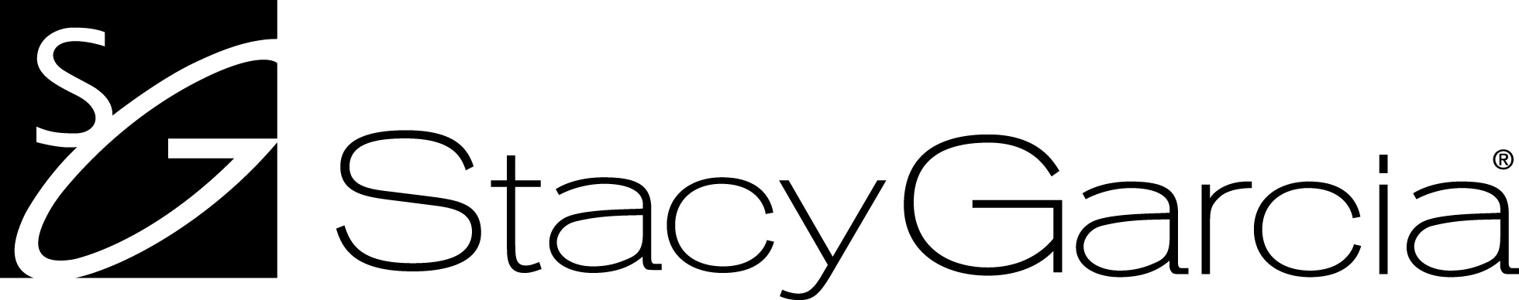

Taking Shape

Pattern Series: SG3120-SG3127 Physical Properties:
Type II • 20 oz. Width: 54”
54” repeat, Straight, Non-Reversible Total Weight (oz./lin. yd): 20.3 oz.
Linen1 Emboss Total Weight (oz./sq. yd): 13.0 oz.
Fabric Type: Non-Woven
Backing Fabric Weight: 1.8oz./sq.yard
Average Total Thickness: 16mils

Federal Specifications:
- This wallcovering meets or exceeds all requirements of G.S.A. Federal Specification
CCC-W-408D for Type II material.

Fire Hazard Classification Results:
Tested in accordance with ASTM E-84 Tunnel Test Flame Spread: Class A Pass
Class A Fire Rated Smoke Developed: Class A Pass

York Quality Standards
- LOW IN V.O.C.’S
INDOOR AIR QUALITY: Low V.O.C. emitting vinyl wallcoverings meets California Department of Health Services section 01350 requirements for office and school interior
- LEED CONTRIBUTION: Can contribute towards LEED points.
- SUSTAINABLE MATERIALS: Printed with water-based inks.
- ENERGY SAVINGS: Improves insulation R-factor by up to 6%
- *Antimicrobial Technology: EPA-Registered Ingredients
- *WARRANTY: 5-year limited warranty against manufacturing defects.

Customs - Available upon request

Vinyl wallcovering has little or no moisture permeability. If the design, construction or maintenance of a building and/or other circumstances allows moisture to accumulate in a wall or wall cavity, vinyl wallcovering can act as a vapor barrier restricting the escape of moisture and increasing the risk of mold growth. Mold and mildew are naturally occurring and are present everywhere in nature. They need only water and organic material [such as wood, paper, or plant material] to feed upon and grow. Vinyl wallcovering permeability can be increased through perforation and alternative product constructions with varying degrees of increased permeability depending on the methods used. No wall surfacing material will prevent mold growth, however, if moisture accumulation is permitted to occur. An experienced professional who is familiar with building conditions and circumstances should be consulted concerning benefits and limitations of vinyl wallcovering.

NOTE: The assigned numerical reading and other tests referenced in this text are not intended to reflect hazards presented by his or any other material under actual fire cognitions. Consult an architect or fire safety engineer for information on applicable building codes and reduction of fire hazards, including the use of sprinklers.

Design Copyright © York Contract

